# Tableau Lab Answer Sheet – Independent Activity Part 1

Use this answer sheet to answer the questions with the **red squares ⬜** from the Tableau Lab (see lab handout for the entire set of instructions). You can include partial screenshots of displays/visualizations if the entire display is too big. We just want to know that you were able to generate the answer/transformation.

**Question 6: Which movies were about dragons?**

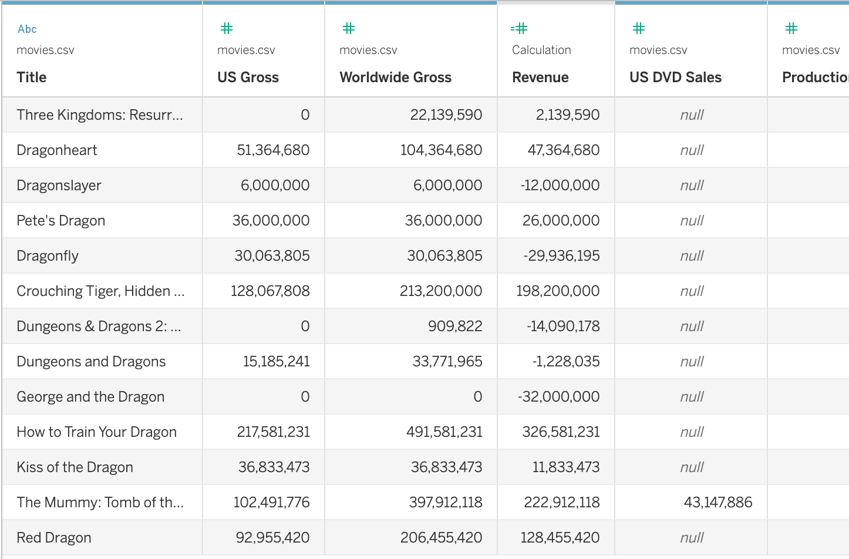

**Ans: The movies above were about dragons.**

**Question 9: Are there directors who have never directed a profitable movie? Who are they?**

**Ans: Yes, there are directors who have never directed a profitable movie. The worksheet below shows all of them.**

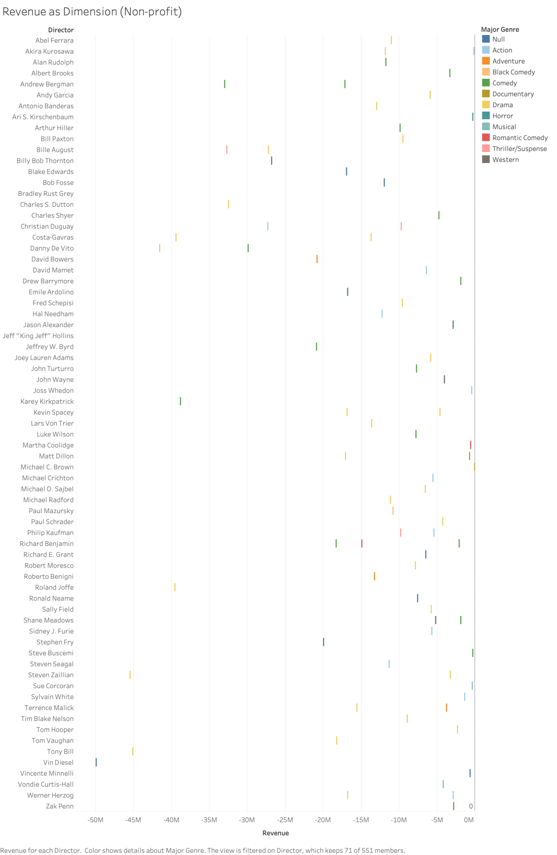

**Question 11: Which director has directed the most profitable Comedy movie?**

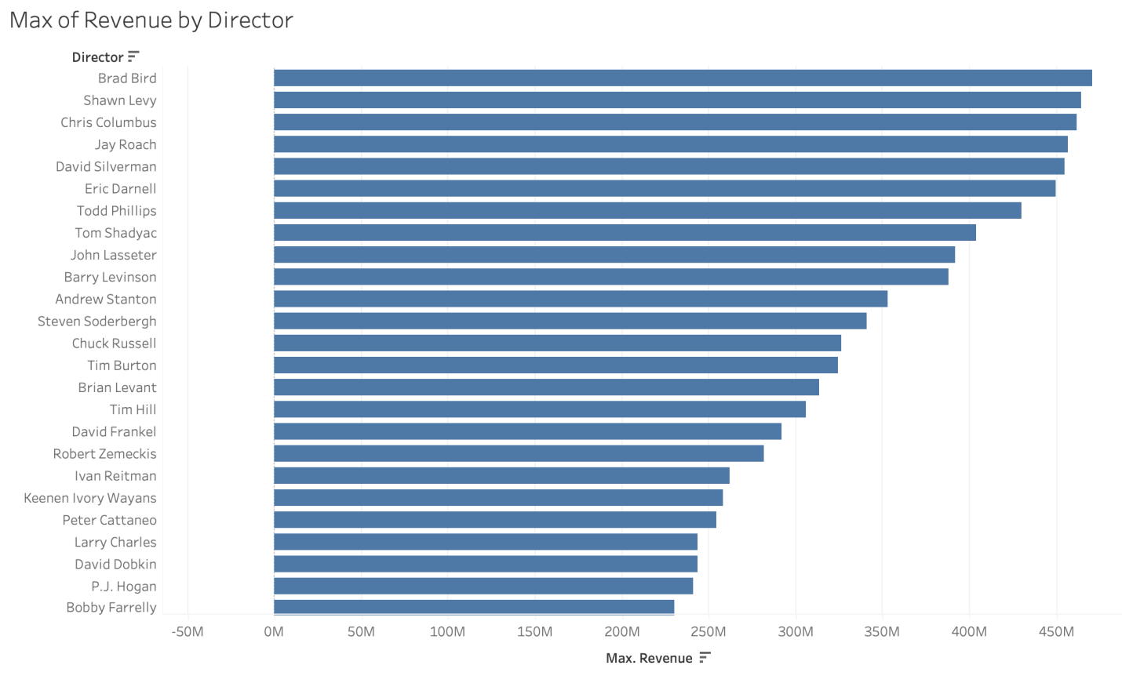

**Ans: Brad Bird has directed the most profitable comedy movie.**

**Question 12: (bonus question): Do movies that contain the word “star” have higher average revenue than movies with “dragon” in the title?**

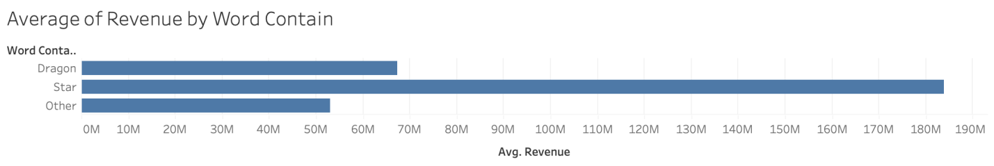

**Ans: Yes, movies that contain the word “star” have higher average revenue than movies with “dragon” in the title.**

**Question 15: Is it better to invest in action movies or comedies? Which director would you invest in?**

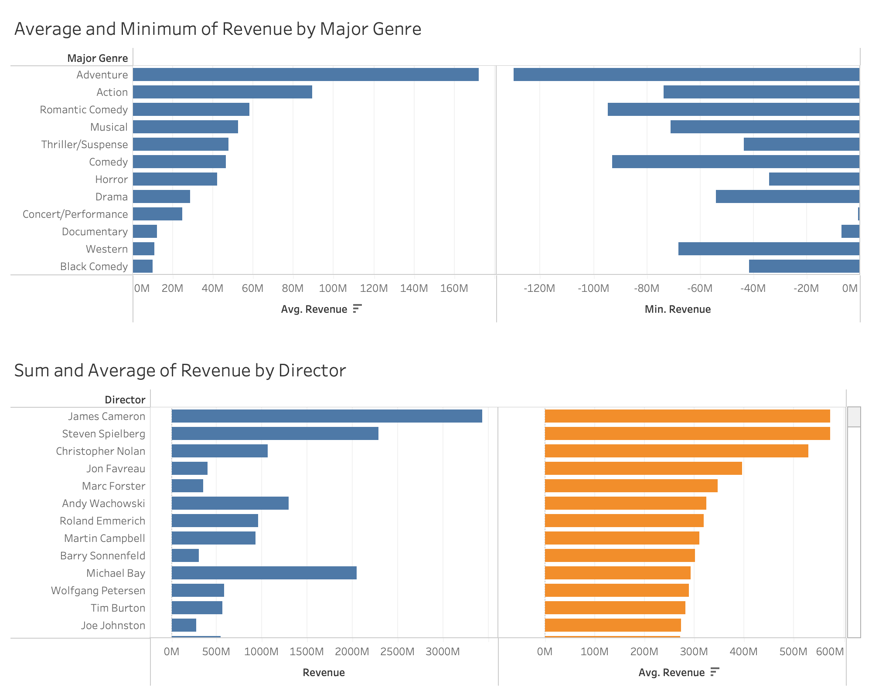

**Ans: I create a Average and Minimum of Revenue visualization by a filter of major genre. I combine this worksheet with the Sum and Average of Revenue by Director in a dashboard.**

**It is better to invest in action movies, as action movies has higher average revenue and higher minimum revenue than comedies.**

**I would invest in James Cameron, as among all the action movie directors, he has both the highest sum of revenue and the highest average of revenue.**

**Question 16: What’s the relationship between IMDB ratings and revenue? Are highly-rated movies more profitable?**

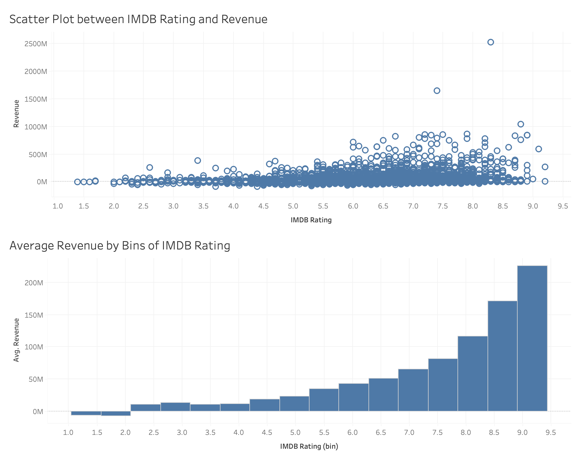

**Ans: I create a scatter plot between IMDB Rating and Revenue, and also Average Revenue by Bins of IMDB Rating.**

**From the visualizations, I conclude that, there is no guarantee that every high-rated movie brings in more revenue, but on average, high-rated movies bring in more revenue overall.**

**Question 18: Who would you invest in?**

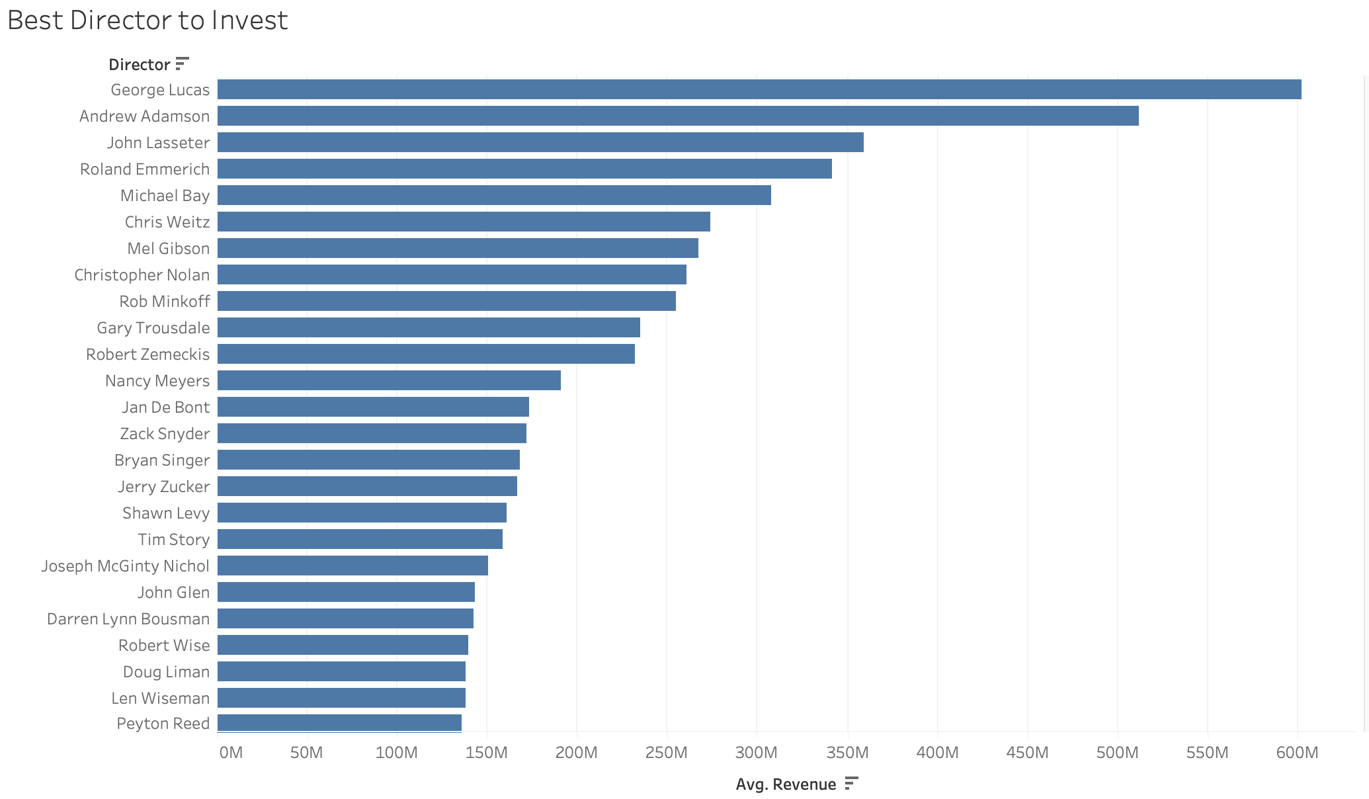

**Ans: I would invest in George Lucas.**

**I implement two filters: First, I select only the directors that has never directed non-profitable movies (i.e. Min([Revenue]) > 0), which is less risky; Second, I select only the directors who has directed more than 2 movies (i.e. COUNT([Title]) > 2), who are more experienced.**

**I then sorted these directors in descending order based on average revenue. The top one is George Lucas, the very director I choose.**